SQL תרגיל College

create tables

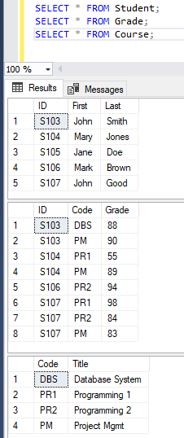

Microsoft SQL Server Queries

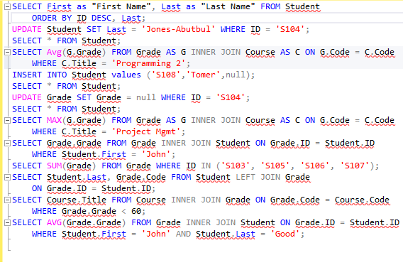

and Results:

|  |  |
| --- | --- |